
SIMATS ENGINEERING
Saveetha Institute of Medical and Technical Sciences
Chennai-602105

AQUAGUARD 360: INTELLIGENT WATER QUALITY MONITORING AND PREDICTIVE CONTAMINATION ALERT SYSTEM

S ROOPAN RAJ(192525474)
B.Tech AI&ML

DECLARATION

I hereby declare that the project entitled "AquaGuard 360: Intelligent Water Quality Monitoring and Predictive Contamination Alert System" submitted in partial fulfillment of the requirements for the award of the degree of Bachelor of Engineering in Artificial Intelligence and Machine Learning is a record of original work carried out by me under the guidance of Dr. ANITADAVAMANI, Department of Artificial Intelligence and Machine Learning, Saveetha Engineering College.
I further declare that this project has not previously formed the basis for the award of any degree, diploma, associate ship, fellowship, or any other similar title in any University or Institution.

Date /08/2026 Signature of the Student
Place: Chennai S. ROOPAN RAJ

ACKNOWLEDGEMENT
I express my sincere gratitude to Saveetha Engineering College, Chennai, for providing an excellent academic environment and the necessary facilities to carry out this project successfully.
I extend my heartfelt thanks to the Principal of Saveetha Engineering College for providing continuous encouragement, motivation, and institutional support throughout the completion of this project.
I express my sincere gratitude to the Head of the Department of Artificial Intelligence and Machine Learning for providing valuable guidance, encouragement, and the necessary infrastructure required for the successful completion of this work.
I am deeply indebted to my project guide, Dr. ANITADAVAMANI, for their constant encouragement, technical expertise, valuable suggestions, and continuous supervision throughout every stage of this project. Their guidance played a vital role in shaping this work into its present form.
I also thank all the faculty members of the Department of Artificial Intelligence and Machine Learning for sharing their knowledge and extending their support whenever required.
Finally, I express my heartfelt gratitude to my parents, family members, friends, and classmates for their unwavering encouragement, motivation, and moral support throughout the development of this project.

1. INTRODUCTION
Modern software applications require continuous development, testing, and deployment to deliver new features quickly while maintaining software quality. Traditional software deployment methods involve manual building, testing, and deployment, which are time-consuming and prone to human error. Continuous Integration and Continuous Deployment (CI/CD) overcome these limitations by automating the complete software delivery process.
AquaGuard 360 is an intelligent water quality monitoring and predictive contamination alert system that integrates Internet of Things (IoT), Artificial Intelligence (AI), Machine Learning (ML), Cloud Computing, Git, and Docker. The application continuously collects water quality data, predicts contamination risks, and generates real-time alerts for water authorities.
Since the project consists of multiple components such as the frontend dashboard, backend APIs, AI prediction module, and database services, frequent code updates require an automated software delivery process. A CI/CD pipeline ensures that every code modification is automatically built, tested, verified, and deployed without manual intervention.

2. PROJECT REQUIREMENT ANALYSIS
The AquaGuard 360 application consists of several independent modules working together to provide real-time water quality monitoring.
The project includes:
- User Authentication
- IoT Sensor Data Collection
- AI-Based Water Quality Prediction
- Alert Notification System
- Dashboard Visualization
- Report Generation
- Database Management
Every modification made to these modules should pass through automated integration, testing, and deployment before reaching production. Therefore, implementing a CI/CD pipeline is essential for maintaining software reliability and reducing deployment failures.

3. CI/CD REQUIREMENTS
To support continuous software delivery, AquaGuard 360 requires a CI/CD pipeline capable of automating the complete software development lifecycle.
The major CI/CD requirements include:
- Source code management using GitHub.
- Automatic build generation after every code commit.
- Automated unit and integration testing.
- Code quality analysis before deployment.
- Docker image creation and packaging.
- Deployment to Development, Staging, and Production environments.
- Continuous monitoring after deployment.
- Automatic notifications for build failures.
- Rollback mechanism in case of deployment errors.
These requirements ensure that every software update is validated before being delivered to end users.

4. CI/CD PIPELINE OBJECTIVES
The primary objective of implementing CI/CD for AquaGuard 360 is to automate software integration and deployment while improving software quality.
The pipeline aims to:
- Reduce manual deployment effort.
- Detect coding errors during development.
- Execute automated testing.
- Improve software quality through continuous validation.
- Deploy stable application versions faster.
- Reduce production failures.
- Support collaborative development.
- Ensure consistent deployments using Docker containers.
These objectives improve both development efficiency and application reliability.

Table 1: CI/CD Requirements
Requirement ID | CI/CD Requirement
CI-01 | Source Code Management
CI-02 | Automated Build
CI-03 | Automated Testing
CI-04 | Code Quality Analysis
CI-05 | Docker Packaging
CI-06 | Continuous Deployment
CI-07 | Monitoring & Notifications
CI-08 | Rollback Strategy

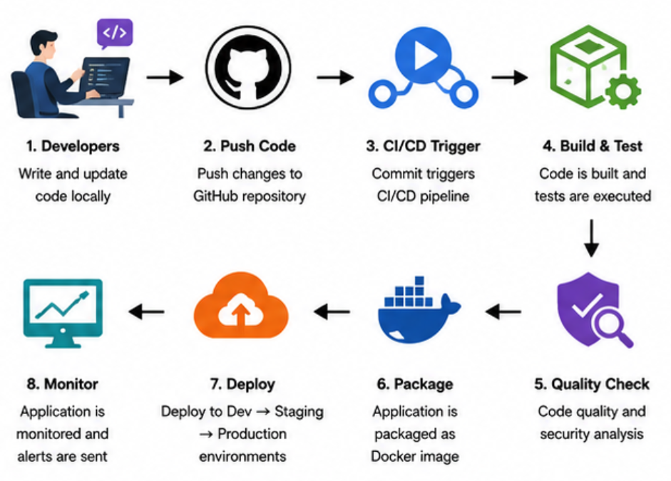

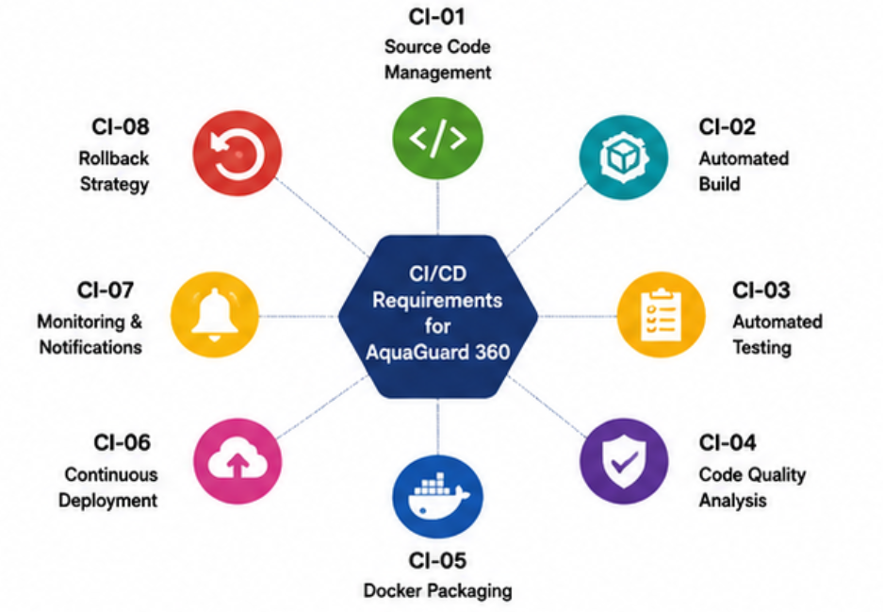
5. NEED FOR CI/CD IN AQUAGUARD 360
The AquaGuard 360 application is expected to receive continuous updates as new AI models, dashboard improvements, and IoT integrations are developed. Performing manual builds and deployments for every update would increase development time and introduce the possibility of configuration errors.
A CI/CD pipeline automates repetitive tasks such as code integration, compilation, testing, packaging, and deployment. Developers receive immediate feedback whenever code changes introduce defects, allowing problems to be corrected before deployment. Automated deployment also ensures that all environments remain consistent, reducing compatibility issues and improving overall software reliability.
By integrating CI/CD into AquaGuard 360, the project becomes more scalable, maintainable, and capable of delivering frequent software updates with minimal downtime.
6. CI/CD PIPELINE WORKFLOW
The CI/CD pipeline begins when developers make changes to the AquaGuard 360 source code and push them to the GitHub repository. Every commit automatically triggers the CI/CD workflow. The pipeline first retrieves the latest source code, builds the application, installs required dependencies, and performs automated testing.
After successful testing, code quality analysis is carried out to detect bugs, code duplication, and security vulnerabilities. If the quality checks are passed, the application is packaged into Docker images. These images are then deployed to the Development environment for initial verification.
Once the application is successfully validated, it is promoted to the Staging environment, where integration and user acceptance testing are performed. Finally, the approved Docker containers are deployed to the Production environment, making the latest version of AquaGuard 360 available to users.

7. TOOLS AND TECHNOLOGY SELECTION
Selecting appropriate tools is essential for building an efficient CI/CD pipeline. Each stage of the pipeline uses specialized tools to automate software development and deployment.
Pipeline Stage | Tool Used | Purpose
Source Code Management | GitHub | Stores and manages project source code
Continuous Integration | GitHub Actions / Jenkins | Automates build and testing
Build Tool | Maven / Gradle / npm | Compiles and builds the application
Automated Testing | PyTest / JUnit | Executes unit and integration tests
Code Quality Analysis | SonarQube | Detects bugs and code smells
Containerization | Docker | Packages the application into containers
Deployment | Docker Compose | Deploys application services
Monitoring | Prometheus & Grafana | Monitors application performance
Notifications | Email / Slack | Sends build and deployment alerts
Each tool is selected based on its reliability, ease of integration, and widespread use in modern DevOps environments.

8. PIPELINE STAGES
The proposed CI/CD pipeline consists of the following stages:
Source Code Management
Developers push code changes to the GitHub repository. Every commit acts as the trigger for the automated pipeline.
Build Stage
The CI server downloads the latest code, resolves project dependencies, and compiles the application.
Automated Testing
Unit tests and integration tests are executed automatically to verify that the application behaves as expected.
Code Quality Analysis
Static analysis tools evaluate the source code for bugs, security vulnerabilities, duplicated code, and coding standard violations.
Packaging
After passing all quality checks, Docker builds a container image containing the application and all required dependencies.
Deployment
The Docker image is deployed to Development, Staging, and finally Production environments after successful validation.

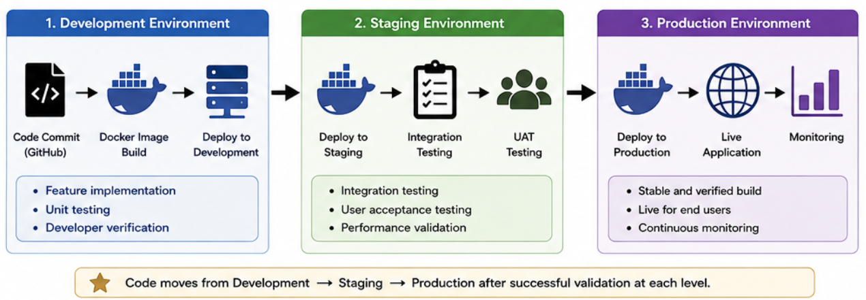
9. BENEFITS OF THE PROPOSED PIPELINE
The proposed CI/CD pipeline offers several advantages for AquaGuard 360:
- Automates repetitive development tasks.
- Detects coding errors early through automated testing.
- Improves software quality with continuous code analysis.
- Ensures consistent deployment using Docker containers.
- Reduces manual deployment effort.
- Supports faster and more reliable software releases.
- Enables collaborative development through GitHub.
- Simplifies maintenance and future enhancements.
By integrating these stages into a single automated workflow, AquaGuard 360 can achieve faster delivery cycles while maintaining high software quality and system reliability.
10. AUTOMATED TESTING STRATEGY
Automated testing is an important stage of the CI/CD pipeline because it validates every code change before deployment. Whenever a developer commits code to the GitHub repository, the CI server automatically executes predefined test cases.
The testing process includes unit testing, integration testing, and basic functional testing. Unit tests verify individual modules such as user authentication and AI prediction, while integration tests ensure that the frontend, backend, database, and AI services communicate correctly. Code quality tools also perform static analysis to detect coding errors, security vulnerabilities, and duplicated code.
By automating testing, defects are detected early, reducing the risk of deploying unstable software to production.

11. DEPLOYMENT STRATEGY
The proposed deployment strategy consists of three environments:
Development Environment
Developers test newly implemented features and verify that the application functions correctly before integration.
Staging Environment
After successful development testing, the application is deployed to a staging environment that closely resembles the production environment. Integration testing and user acceptance testing (UAT) are performed here.
Production Environment
Only builds that successfully pass all automated tests and quality checks are deployed to production. This ensures that users always receive a stable version of AquaGuard 360.
The deployment process is fully automated using Docker containers, ensuring consistency across all environments.

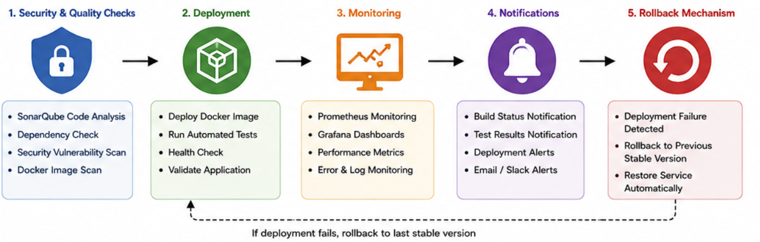

12. SECURITY, MONITORING & ROLLBACK
To improve software reliability, the CI/CD pipeline integrates several security and monitoring mechanisms.
Code quality analysis tools scan the source code for security vulnerabilities before packaging. Docker images are validated to ensure that only trusted containers are deployed. After deployment, monitoring tools continuously observe application performance and resource utilization.
Whenever a build fails or deployment encounters an error, automatic notifications are sent to developers through email or messaging platforms such as Slack. If production deployment fails, the pipeline automatically restores the previously stable Docker image using the rollback mechanism. This minimizes downtime and ensures uninterrupted service.

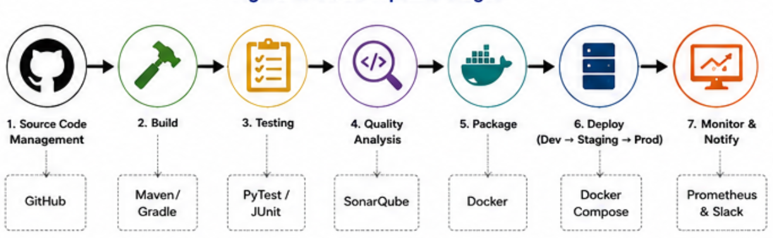

13. CONCLUSION
The proposed CI/CD pipeline for AquaGuard 360 automates the complete software delivery lifecycle, beginning with source code integration and ending with production deployment. Automated building, testing, code quality analysis, Docker packaging, and continuous deployment improve software reliability while reducing manual effort.
The inclusion of security scanning, monitoring, automated notifications, and rollback mechanisms further strengthens the deployment process by ensuring that only verified application versions reach production. This pipeline supports faster software delivery, improved collaboration, easier maintenance, and higher application availability.
Overall, the proposed CI/CD architecture provides a scalable and reliable DevOps solution for AquaGuard 360, enabling continuous enhancement of the intelligent water quality monitoring system.

REFERENCES
- GitHub Documentation.
- Jenkins Documentation.
- Docker Documentation.
- SonarQube Documentation.
- Prometheus & Grafana Documentation.
- Ian Sommerville, Software Engineering, 10th Edition.
- Roger S. Pressman, Software Engineering: A Practitioner's Approach, 9th Edition.

